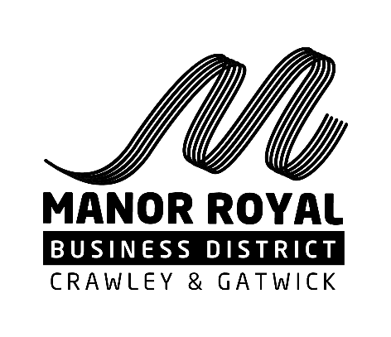

www.manorroyal.org/pmp
MANOR ROYAL PARKING MANAGEMENT PLAN (PMP): FEEDBACK FORM 2022
Two years ago Manor Royal businesses tended to support the idea for introducing a parking permit scheme that would require permits to be purchased to park in public areas of the Business District and allow better control of available space for staff and visitors. However, COVID stalled introduction of the scheme.
Before it is progressed by the Local Authorities, the Manor Royal BID is undertaking a further consultation with Manor Royal businesses to make sure there is still support for the scheme.
Use this form is to feedback your thoughts, including any ideas that might help improve it.
You can return completed forms by email to steve@manorroyal.org or by post the Manor Royal BID, Unit 38 Basepoint Business Centre, Metcalf Way, Crawley, RH11 7XX
Name
Title
Business
Address
Email |  | Phone
- Is parking an issue that affects you/your business/staff? |  |  |  | Yes |  | No
- Does your business have enough on-site parking? |  |  |  | Yes |  | No
- Do you support the proposals to manage parking in Manor Royal for businesses, staff and visitors? |  |  |  | Yes |  | No
- Are the proposed fees (circa £150 per annum) for the proposed permits reasonable? |  |  |  | Yes |  | No
- Any other comments? (Use the space provided to make specific observations about the proposed plan, any changes you would like to see or parking matters generally as they impact Manor Royal)

